Crimson Hearts

by Literary Titan

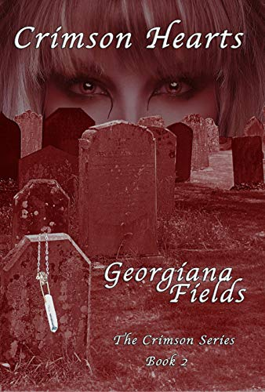

Crimson Hearts, Book 2 in The Crimson Series by Georgiana Fields, is a fast-paced paranormal romance novel. That might sound like a mouthful, but Fields effortlessly balances each of these facets – the mystery, the romance, the fantasy – in a way that will leave readers happily racing through the pages and into Book 3 of the series (of which Fields kindly includes a chapter!). I was not sure what to expect in Crimson Hearts, given it was Book 2 in the series and I had not read Book 1, but Fields delighted me at every turn with a thoughtful novel that anyone can enjoy.

Crimson Hearts creates a story that is both fun and racy while also being thoughtful and deep. At just under 300 pages, it’s long enough to really sink your teeth into (pun definitely intended), and it is not necessary to have read Book 1 in the series. The story centers on Caitlin MacPhee, an investigative journalist by day and vampire by night, and Raven O’Brien, her love interest and local detective, as they pursue a deranged serial killer who is hell-bent on punishing women for practicing witchcraft. Caitlin soon finds herself at the center of the chase instead of just reporting on it, all while balancing the stresses and passions of a new relationship. Throw in a few feisty bloodthirsty extended relatives with a myriad of supernatural powers for good measure, then just sit back and enjoy the fun ride of Crimson Hearts.

What I particularly enjoyed about Crimson Hearts was how wonderfully Fields balanced both the supernatural with the everyday mundane. She builds a wonderful world of history, legends, and laws around Caitlin’s vampire ancestry, while also perfectly capturing the quotidian pains of normal human life. The awkwardness of a first kiss, the pain of a Monday morning alarm clock, the anxiety of plotting your escape from a blind date – these are all things to which readers can humorously relate. But, don’t forget the blood in the fridge in case you need a refreshing beverage, sweetie! With Caitlin, Crimson Hearts has a protagonist that you can root for and feel like she could be your friend, while also being amazed at her strength and supernatural gifts.

Of course, it is also worth mentioning that Fields has littered the novel with delightful little romance scenes. She skillfully balances a fine line, creating love scenes that are both passionate and thrilling while still feeling tactful – like you wouldn’t be too embarrassed if someone caught you reading them because, come on, it’s a hot vampire love scene!

Crimson Hearts succeeds because it is well-written, creative, and genuine. It is undoubtedly well-written – the dialogue is crisp, the syntax is professional, and every page serves a purpose. The story itself is creative, full of twists and turns, but also littered with clues to keep readers engaged. The characters, both leads and supporting, feel like real-life people you could know personally. Though social distancing has limited some of the typical springtime activities I love, I am incredibly glad that this time of social distancing has introduced me to the thrills of Georgiana Fields’ Crimson Series. While there is less excitement in my life, I know that I will be able to find it in surplus in the pages of her writing.

